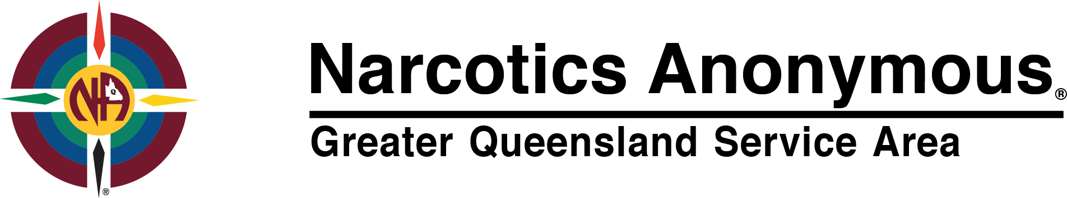
Financial Statement @ 8 February 2018.

Bank of Queensland Business account # 13201668 current balance: $7,034.33

Bank of Queensland Convention account #20988136 current balance: $6,006.77

Attached below are bank statements for the last 3 months from this date.
Attached is a rolling financial ledger for the last 3 months.

For fund flow to Greater Queensland Service Area, deposit can be made to:

Name of Account: Queensland Area Service Committee
BSB: 124 026
Account No: 13201668
Please be sure to put a name to the deposit so we can identify where the fund flow has come from, for instance the name of your home group meeting.

YIS

Nick C – NA Greater QLD Service Area Board member.

0421 473 881

