Proposal to the Queensland Service Board for the 2019 Area Convention
Queensland Convention of NA - Cairns – 26, 27 & 28 July 2019
Committee; Hamish (bid committee chair), Tony, Ange, Fiona, Ben, Julie & Damon.

Our goals are:

- To host an event that celebrates recovery for recovering addicts, from the Queensland Area and beyond.
- To create an opportunity for addicts to become involved in NA service and work with a committed group of willing addicts to create a celebration of recovery.
- Have the opportunity for local members to attend a convention and experience the benefits of fellowship.
- To create a fun, celebration of recovery.

The Bid Committee has met numerous times since June 2016 and has put this Bid together in good faith.
We are intending this Bid to be made via email to the Queensland Service Board in Brisbane on Saturday 26 May 2018.

Name/Theme
“To be advised”
We have yet to confirm a name theme for the convention.
We as a Committee are not planning on organising a dance or entertainment. Past experience has proven this to be a costly and energy/time-consuming exercise.
We in FNQ have a culture of sharing food after a meeting. In this tradition we will be exploring options to share food together as an alternative to entertainment or a dance.

Dates
Friday 26, Saturday 27 & Sunday 28 July 2019. The weekend is later than the previous Cairns 2016 Convention to enable it to be a bit warmer for our southern members to come and bask in the relative warmth of winter in Cairns. This is also (I understand) the weekend after the July 2019, Regional Service Committee meeting in Brisbane.

Venue
The Convention will be hosted at:

The Novotel Cairns Oasis Resort, Conference and meeting rooms, situated in Central Cairns at 122 Lake Street, Cairns 4870. www.novotelcairnsresort.com.au

This is the central pool area. The main meeting room is off the pool area and the café is on the pool area.
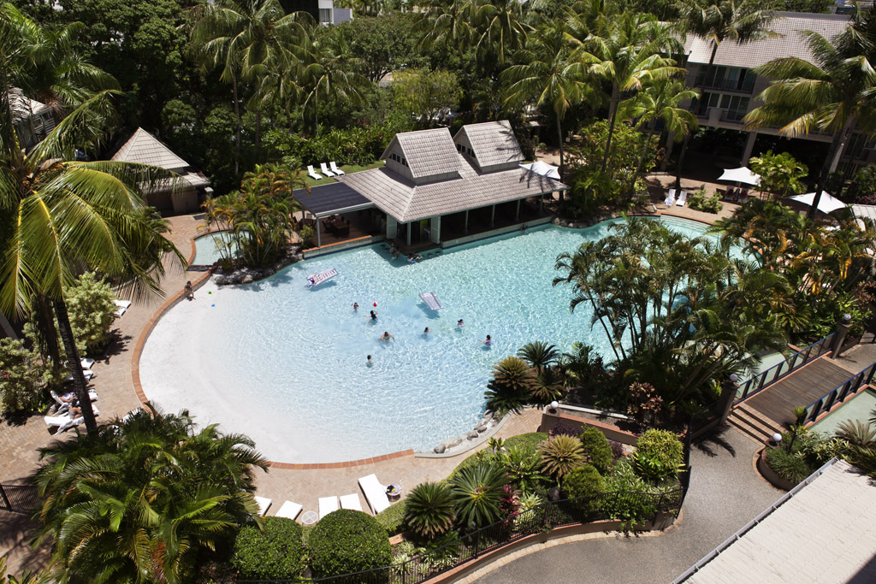
The Convention registration area would go here adjacent to the reception & café area.
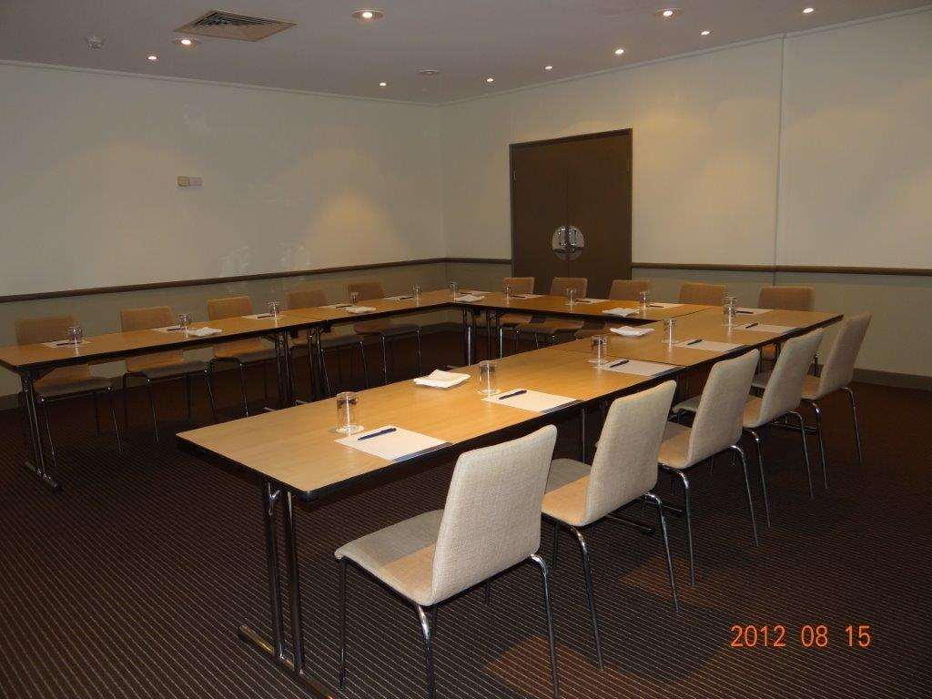
The main meeting space is just off the terrace that surrounds the pool area.
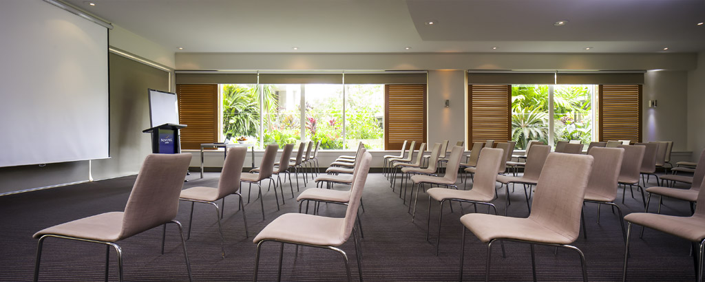

This is where the pool area is and there is provision to host a dinner on the Friday (Fish & Chips) and Saturday (Pizza & Salad) nights.
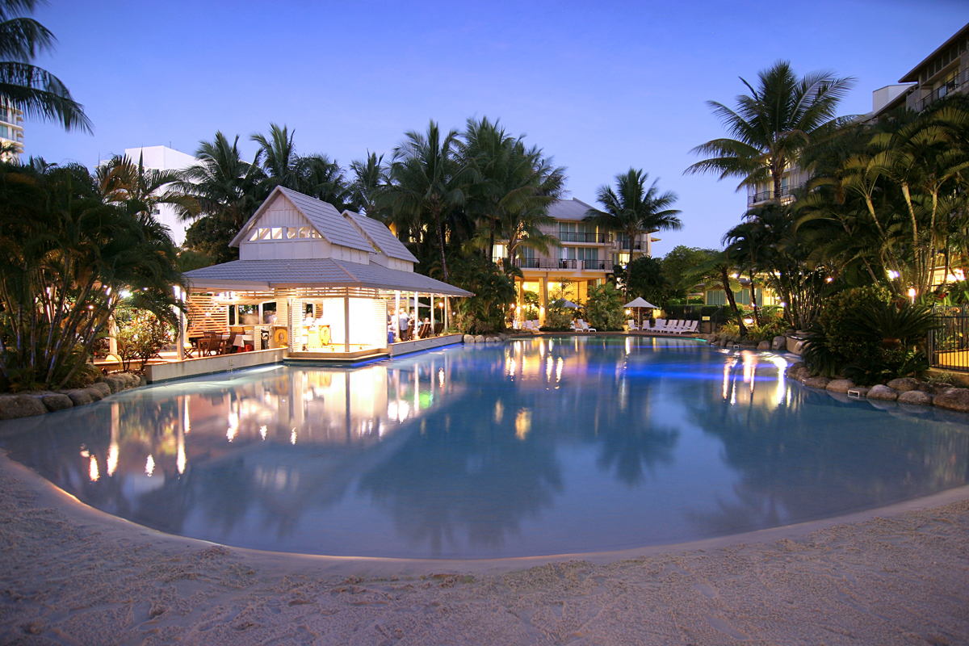

The Novotel Cairns Oasis Resort is located at 122 Lake Street, Cairns. All within walking distance of plenty of cafes, restaurants and food halls and a few blocks from the night Market, Rusty’s market for tropical fruit, the Esplanade swimming pool lagoon and The Esplanade walkway and board walks.
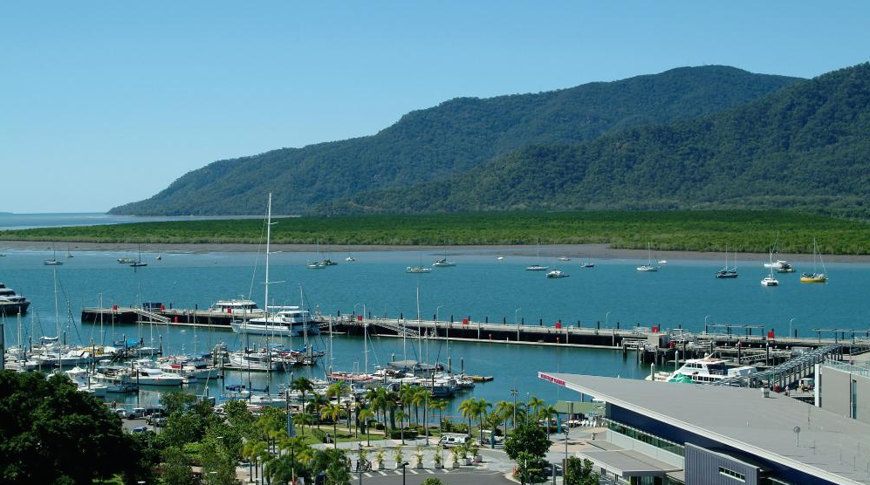
Programme:

Meeting themes/topics/names would be in relation to positive NA recovery topics and literature.

There can be some provision within the programme for service discussions and workshops throughout the weekend.

Common Needs meeting be reflective of the diversity of the Area Fellowship. Men’s, Woman’s, and GLBTI. Are there any other Common Needs?

The Closing speaker meeting is proposed for 3pm to 4.30pm to allow people driving back to Townsville time to do so.

Accommodation:
The Novotel Cairns Oasis Resort has offered accommodation rates at $169.00 per room per night for one person including buffet breakfast. There is also a wide range of standards of accommodation available in close proximity to the Convention Venue.

Accommodation rates would be $169.00 per room per night for one person including buffet breakfast and $189.00 for a twin-share room or double occupancy

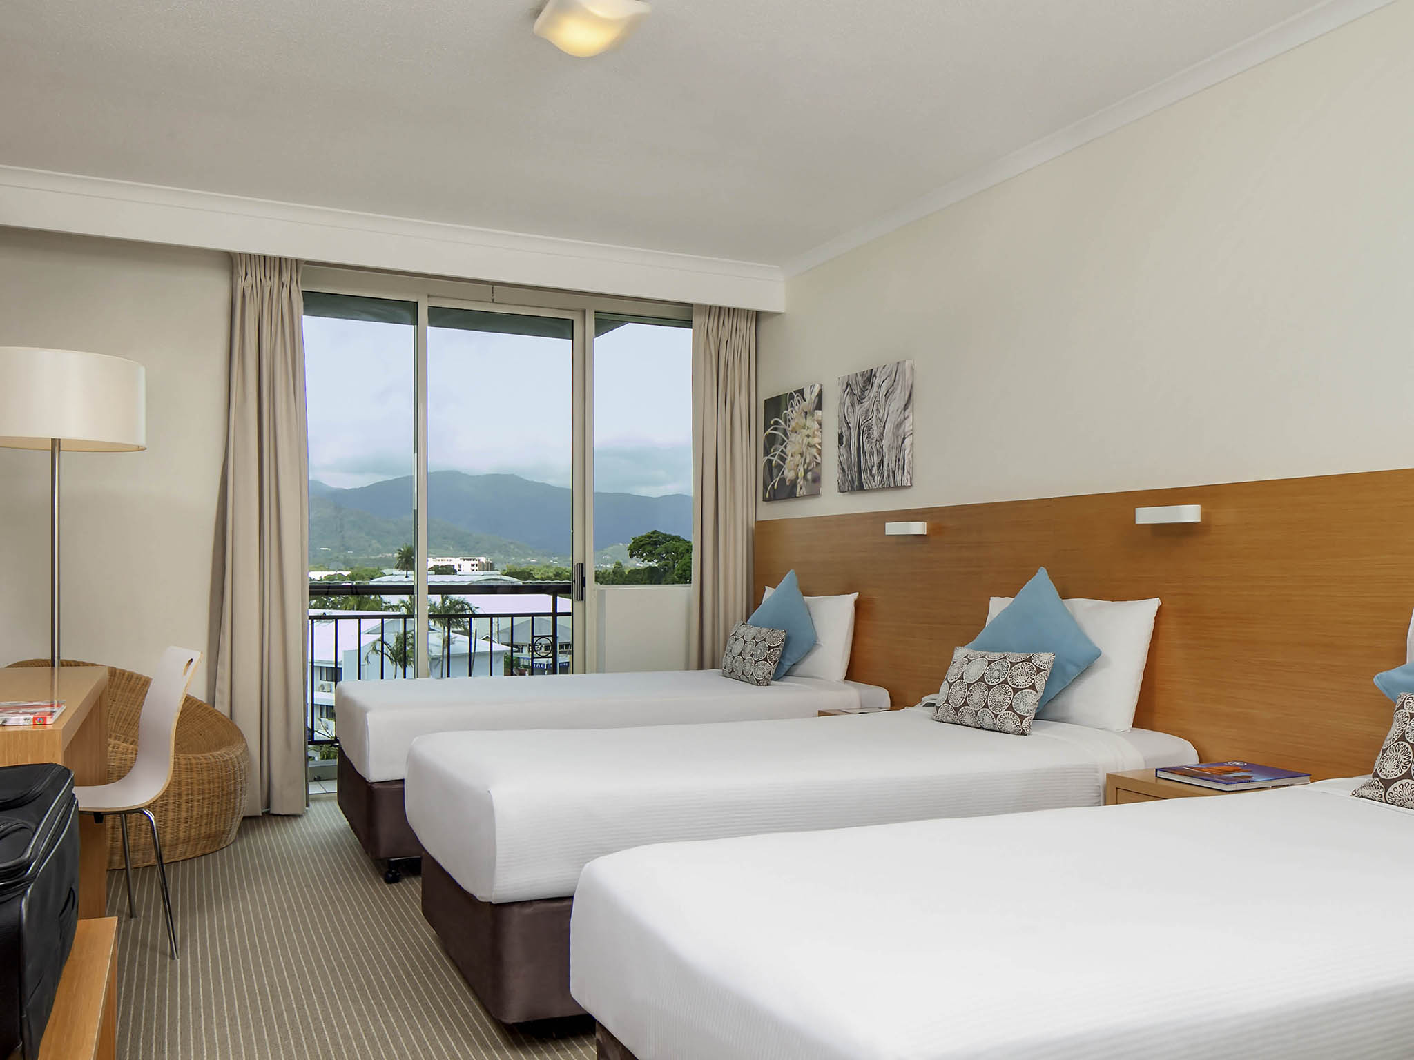

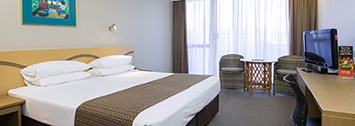
Food:
There is a café straight outside the door that we have negotiated to have open during the conventions as well as the poolside café area.
Otherwise there are many cafes, restaurants or food halls near by.

Communication
We will email the Queensland Area Board Convention Planning Committee minutes as well as any other interested Board or Area members.

Meetings and Minutes
The Convention Committee meeting will be meeting regularly and will keep records of these meetings and will circulate as above.

Fundraising
We are not anticipating doing any fundraising prior to this event.

Should the Queensland Area like to create “pre-convention “ merchandise to sell prior to the event. They would be welcome to do so. We would create a very small amount of merchandising to be sold at the event. However, this is dependent on resources within the local fellowship being available.

Bank Account
We would like access to the Area Convention account. As long as it has online capability, or we would prefer to open an account.

Financial Plan/Draft Budget
Incoming: Seed money from ASC $3,500
Registration 7,775 (95 people x $45.00)
Auction and Raffles 600

Sub total $11,875

Outgoing: Venue hire 2,900
Flyers and postage 600
Return Area seed money 3,500

Sub total $7,000

Total to offer back to the Area $4,875.00

Please note we are not including any merchandising at this time, however, we will consider the possibility of presales through registration.

We would of course have a facility for newcomer donations to be collected and this would then be utilized to support newcomers wishing to attend the Convention.

We would also include an “unwaged” registration rate.

We need to tidy the budget to include more detail once the bid has been accepted.

Next Steps
Outcome from May 2018 Queensland Service Board – If approved:
Financial implications to the GQASC are $3,500 in seed money.

- Agree to a bank account
- Pay the venue deposit
- Set up the venue payment schedule

We have a copy of the Greater Queensland Area - Convention Policy and are happy to use them in the spirit they are offered to us.

We appreciate your attention in considering this Bid and thank you for allowing us this time. We are very committed to serving the fellowship in organizing this Convention. We wish you well for the Local Service Conference and Queensland Service Board meetings.

I would be happy to answer any questions via phone if you would like 0478 078 456

Many thanks
Yours in loving service
Hamish (bid committee chair), Tony, Ange, Fiona, Ben, Julie & Damon

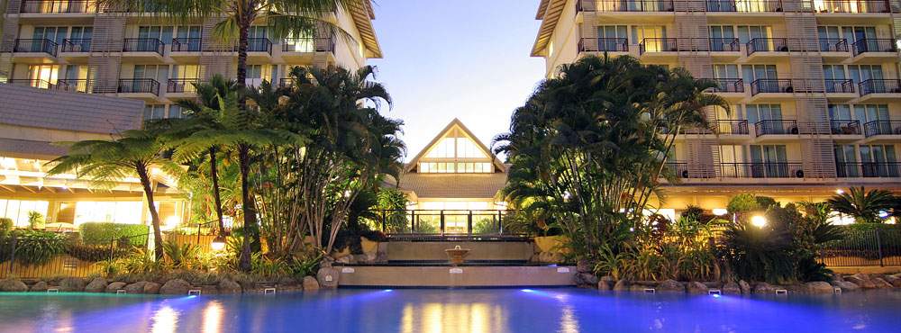

Just in case a NA Convention in the Tropics isn’t enough for you…… here are some other attractions.

Centre of Contemporary Arts Cairns, Cairns Aquarium and Cairns Museum are both within 500meters of the venue.

The Great Barrier Reef

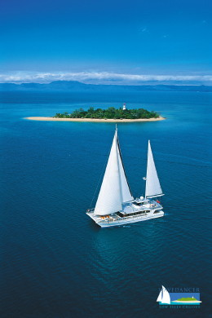
A trip to the magical underwater world of the Great Barrier Reef is a must.
Enjoy a day cruise to one of the Islands, a Coral Cay or to the Outer Barrier Reef. You could even take a scenic helicopter flight over the Great Barrier Reef and tropical Rainforests. Great Barrier Reef Day Tours…

World Heritage Rainforests
Skyrail Rainforest Cableway, and Kuranda Scenic Rail are two spectacular ways to see Tropical North Queensland. Glide over World Heritage rainforest aboard Skyrail, return to Cairns onboard the historic Kuranda Scenic Rail; an ideal way to experience scenic highlights as you wind your way home through the mountains. Kuranda Day Tours…
There are also many National Parks with walking trails on the Atherton Tablelands, Mossman Gorge and Cape Tribulation and many more. Many 4WD day trips to Cape Tribulation and the Daintree Rainforest can be booked. Daintree Rainforest Day Tours…
For further information on the ancient Tropical North Queensland’s World Heritage Rainforests please visit the officialWet Tropics website.

The Australian Outback
Discover the genuine Australian Outback, less than 90 minutes drive west of Cairns. Safari tours are a great way to see the Outback. Visit Undara Volcanic National Park and explore the world-renowned Undara Lava Tubes, or take an extended trip to Cooktown, Chillago and the Cape York area.
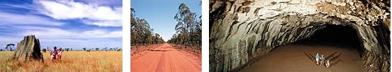

Around Cairns
Take a leisurely stroll along the 2.5 km long Cairns Esplanade.

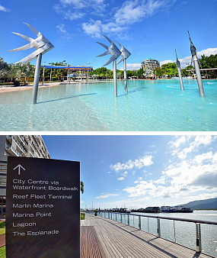
You’ll find many souvenir and craft shops selling all types of interesting keepsakes. The major shopping centre in the City is Cairns Central, which is a short walk from the Pacific Hotel Cairns.
Local markets are a great place – products range from jewellery and pottery to all sorts of artwork, clothes, homemade food and unique Australian goods.
Cairns Night Markets are open every night from 4pm to 11pm and Rusty’s Markets are open every Fri and Sat from 7am to 3pm and Sundays from 7am to 2pm.

