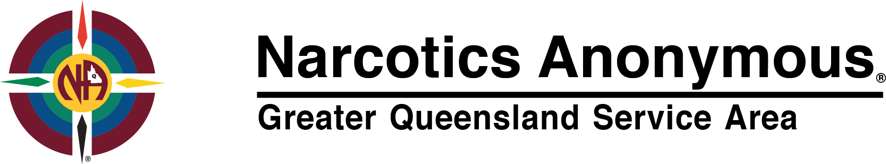
Financial statement @ 23/5/2018

Bank of Queensland Business account # 13201668 current balance: $4,776.21

Bank of Queensland Convention account #20988136 current balance: $6,265.16

Note: Regarding QLD Convention account: $256.20 has been deposited into this account by Sat. Night New Farm meeting, I am assuming this fund flow was deposited into the incorrect account.

Attached are bank statements for the last 3 months from this date (see separate documents)

For fund flow to Greater Queensland Service Area, deposit can be made to:

Name of Account: Queensland Area Service Committee
BSB: 124 026
Account No: 13201668

Please be sure to put a name to the deposit so we can identify where the fund flow has come from, for instance the name of your home group meeting.

YIS

Nick C – NA Greater QLD Service Area Board member.

0421 473 881

